Do You Use Drugs?
Reading This Could Save Your Life!

WARNING: Suspected Poisonings in Peterborough, January 9, 2023

Peterborough Public Health reports high numbers of suspected drug poisonings in the community. This is suspected to be the result of an opiate product that is pink in colour and has an increased level of toxicity. This serves as an important reminder that the street drug supply is unpredictable and harm reduction practices are essential. Beware that using even a small amount of drug can be fatal.

What to do if you inject, inhale, snort or ingest drugs:
- Drug poisoning is possible from inhaling drugs.
- Never share supplies. Avoid using damaged or modified pipes/needles.
- Don’t use drugs alone. Visit the Consumption Treatment Services site at 220 Simcoe Street (open 9:30am -8:00pm, 7 days/week).
- If using with a friend, do not use at the exact same time.
- Have a plan - Ask someone to check on you or call the National Overdose Response Service
1-888-688-6677.
- Carry a naloxone kit. Keep it visible and close by.
- Avoid mixing drugs.
- Test your drug by using a small amount first.
- Call 911 immediately if someone cannot be resuscitated after naloxone is administered.

Under Canada’s Good Samaritan Drug Overdose Act, if you seek medical help for yourself or for someone else who has overdosed, YOU WILL NOT be charged for possessing or using drugs for your own use.
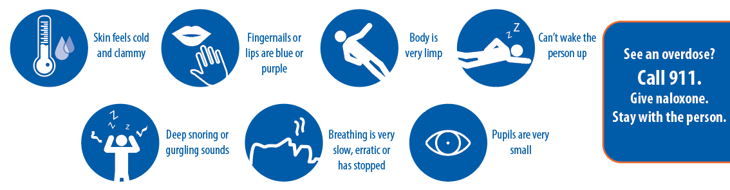
Signs of POISONING:
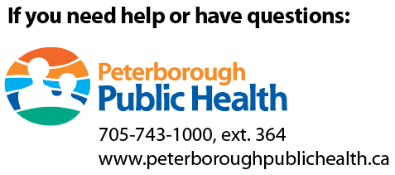
To get naloxone contact:
Peterborough Public Health... 705-743-1000
PARN... 705-749-9110
FourCAST... 705-876-1292
The Elizabeth Fry Society… 705-749-6809
705-743-1000
www.peterboroughpublichealth.ca
360 Clinic... 705-874-3900
Canadian Mental Health Association... 705-748-6711
Curve Lake Health Centre... 705-657-2557
Mobile Support Overdose Resource Team (MSORT)… 705-760-0673
Participating Pharmacies
Other... ontario.ca/naloxone
To seek professional help for drug and alcohol use contact:
Rapid Access Addiction Medicine (RAAM) Clinic
360 George Street North, Peterborough
Open: Monday, Wednesday, Friday: 8:00 – 12 a.m. Phone: 705-749-9708

